Summary of data used

Project report

*Of Business Intelligence for Financial Services*

Table of Contents:

* Summary of data used
* Descriptive Statistics
* Forecast analysis
* Trading strategy
* CAPM
* Wallet
* Conclusions

Poli Luca 852027

18/01/2022

Three stocks were chosen for each of the three sectors: banking, automotive, wireless and semiconductor

# **Banking sector**

It represents a very attractive choice at this time for several reasons.

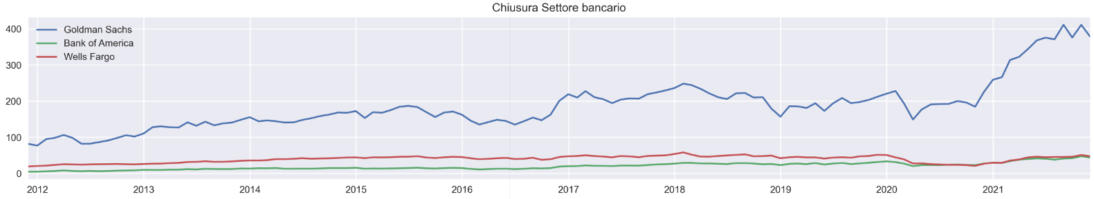It is a very robust sector that is resistant to volatile and uncertain periods; it generally pays good dividends. In addition, it could benefit from inflation and rising interest rates; finally, it is less overvalued than other sectors (such as technology), and therefore more attractive for investment.

## Goldman Sachs - WikipediaGoldman Sachs

It is one of the [world](https://it.wikipedia.org/wiki/Mondo)'s largest [merchant banks](https://it.wikipedia.org/wiki/Banca_d%27affari), headquartered in New York City, with major branches in the world's major financial centers as well

Primarily engaged in [investment banking](https://it.wikipedia.org/wiki/Banca_d%27investimento) and [equities](https://it.wikipedia.org/wiki/Titolo_(finanza)), [asset management](https://it.wikipedia.org/wiki/Risparmio_gestito), and other [financial services](https://it.wikipedia.org/wiki/Servizi_finanziari), mainly with institutional investors ([multinational corporations](https://it.wikipedia.org/wiki/Multinazionale), [governments](https://it.wikipedia.org/wiki/Governo), and individuals)

It was chosen because it appears to be very solid and growing, in fact we can see from the graphs that as net profits go up the number of shares outstanding goes down:

## 

## 

## Bank of America

It is a [multinational](https://it.wikipedia.org/wiki/Multinazionale) [U.S.](https://it.wikipedia.org/wiki/Stati_Uniti_d%27America) [bank](https://it.wikipedia.org/wiki/Banca) and financial services company with headquarters in Charlotte, [North Carolina](https://it.wikipedia.org/wiki/Carolina_del_Nord) and central hubs in [New York](https://it.wikipedia.org/wiki/New_York), [London](https://it.wikipedia.org/wiki/Londra), [Hong Kong](https://it.wikipedia.org/wiki/Hong_Kong), [Minneapolis](https://it.wikipedia.org/wiki/Minneapolis) and [Toronto](https://it.wikipedia.org/wiki/Toronto).

It is the second largest banking institution in the United States, after [JP Morgan Chase](https://it.wikipedia.org/wiki/JP_Morgan_Chase). As part of the [Big Four](https://it.wikipedia.org/wiki/Big_Four), it provides about 10.73 percent of all U.S. bank deposits, competing directly with [Citigroup](https://it.wikipedia.org/wiki/Citigroup), [Wells Fargo](https://it.wikipedia.org/wiki/Wells_Fargo) and JPMorgan Chase. Its main financial services revolve around commercial banking, wealth management and investment banking.

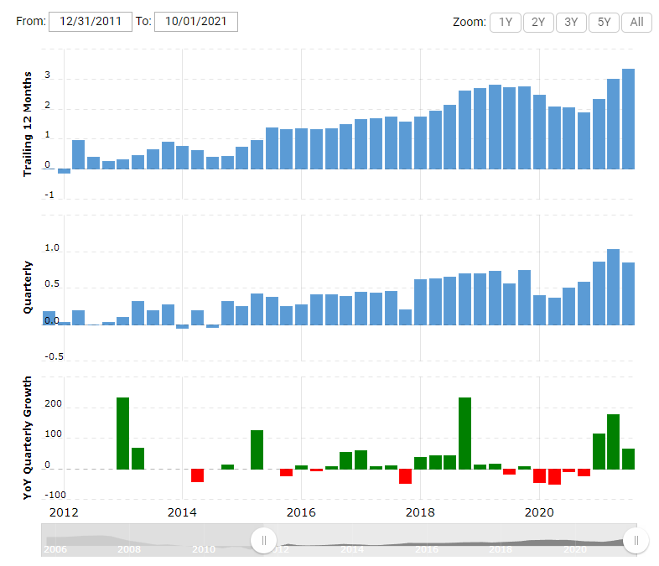Again, the company is in a strong period of growth, as we can see from the news and the earnings per share (EPS) graph

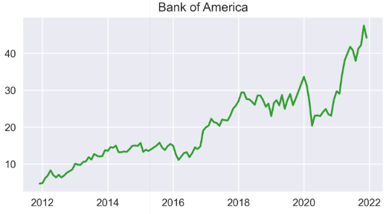

## Wells Fargo

Wells Fargo & Co is a U.S. multinational financial services company headquartered in San Francisco, California, and operating worldwide. Wells Fargo is one of the four largest banks in the United States along with Bank of America, Citigroup, and JP Morgan Chase. Specifically, it is the fourth largest bank by assets, the third largest by [U.S.](https://it.wikipedia.org/wiki/Stati_Uniti) stock market capitalization, and the second largest by deposits, mortgage services, and debit cards.

As can be seen from the news and graphs, it represents a solid and more stable choice

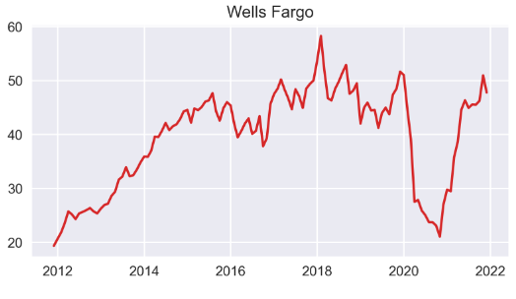

# **Automotive Sector**

It has been under scrutiny because of the push in recent years towards electric. This is a very important step in reducing the environmental impact of automobiles, and one that is now also obligated by legislation in more developed countries.

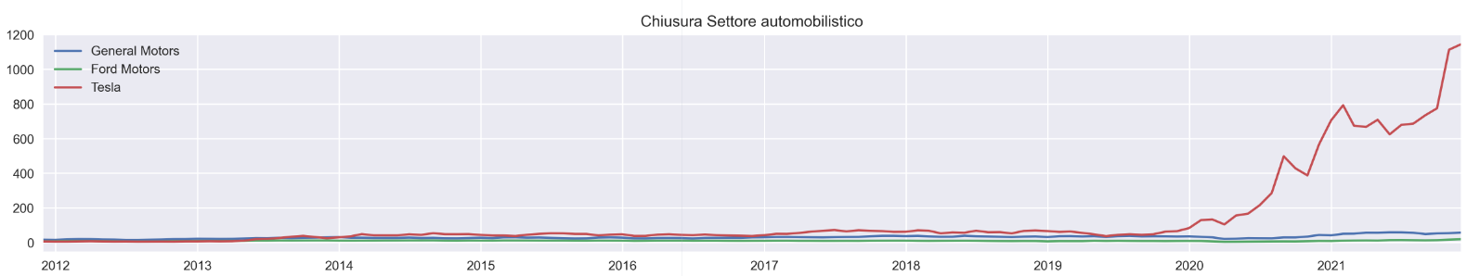So, the stocks examined represent some of the best companies that have, or are, developing in this area

## LogoGeneral Motors

The General Motors Corporation, also known as GM, is a U.S. automobile manufacturing company with brands around the world such as: Cadillac, Chevrolet, GM Korea, GMC, and Buick. It is headquartered in the Renaissance Center in Detroit, Michigan. The company is the largest U.S. automaker and one of the largest in the world.

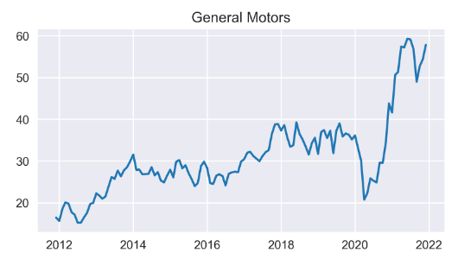It, in addition to being very solid, is one of the candidates for strong expansion in the electrical sector

## Ford Motors

Ford Motor Company is an [American](https://it.wikipedia.org/wiki/Stati_Uniti_d%27America) [automobile manufacturer](https://it.wikipedia.org/wiki/Casa_automobilistica), founded by Henry Ford in Dearborn, Michigan in [1903](https://it.wikipedia.org/wiki/1903).It is known for first using the [assembly line](https://it.wikipedia.org/wiki/Catena_di_montaggio) and [conveyor belt](https://it.wikipedia.org/wiki/Nastro_trasportatore), later adopted by many other companies and still used in modern industries. Automobiles are the group's main product. Approximately 170 models have been produced in more than a century, and some of them have been produced over several generations.

Ford is also a viable competitor for the electric sector

## 

## 

## Immagine che contiene testo, clipart, ascia Descrizione generata automaticamenteTesla

Tesla, Inc. is a U.S. company specializing in the production of electric cars, photovoltaic panels and energy storage systems. It is named after the well-known inventor Nikola Tesla.

The company's goal is to "accelerate the world's transition to the use of renewable energy sources." This includes the production of high-performance electric vehicles geared toward the mass market.

Tesla, despite being very new, owns a very important part of the electric market.

However, it now represents an overvalued stock even though its profit margins are very much on the rise

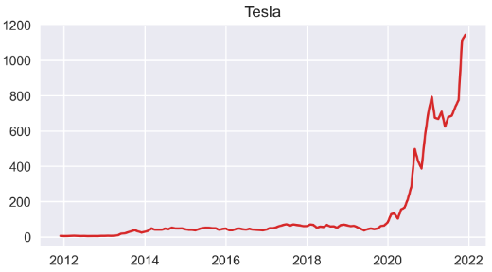

# **Wireless and semiconductor industry**

The wireless sector is becoming increasingly important and fundamental in today's technologies. It might be interesting to invest in companies that specialize in this area (Qualcom and BroadCom), or in companies that produce the chips used (such as Intel)

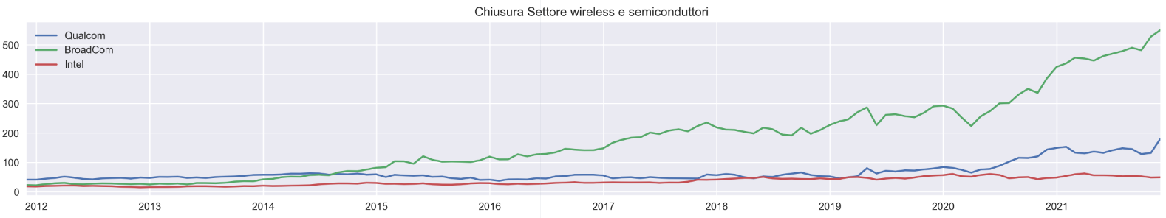However, this sector is greatly affected by the recent semiconductor crisis

## Qualcom

LogoQualcomm is a US-based wireless telecommunications research and development company based in [San Diego](https://it.wikipedia.org/wiki/San_Diego), [California](https://it.wikipedia.org/wiki/California), [USA](https://it.wikipedia.org/wiki/Stati_Uniti_d%27America).

Qualcom is among the top 5 semiconductor manufacturers by sales worldwide, developing them directly while not producing them in-house, relying on third-party companies for this purpose

As you can see from the growth and news, it is a booming stock

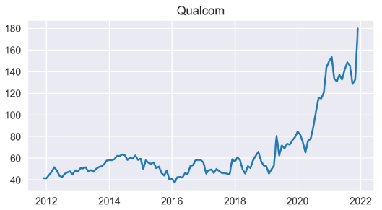

## LogoBroadcom

Broadcom Corporation was a [U.S.-based](https://it.wikipedia.org/wiki/USA) [multinational corporation](https://it.wikipedia.org/wiki/Multinazionale) based in Irvine, California, involved in [semiconductors](https://it.wikipedia.org/wiki/Semiconduttore), integrated circuits, and telecommunications networks. In 2015 it was acquired by Avago Technologies, a major [Singapore-based](https://it.wikipedia.org/wiki/Singapore) chip company, with which it later merged. It will take the name Broadcom Inc but the BRCM symbol will be retired.

It represents an attractive choice for exposure to this market, or for monitoring the consequences of the chip shortage

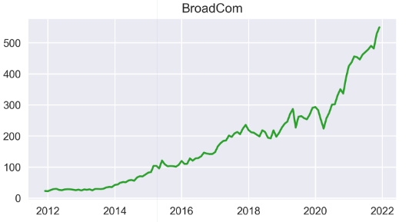

## Intel

Intel Corporation is a [U.S.](https://it.wikipedia.org/wiki/USA) [multinational](https://it.wikipedia.org/wiki/Multinazionale) [corporation](https://it.wikipedia.org/wiki/Azienda) founded on July 18, 1968 with headquarters in [Santa Clara](https://it.wikipedia.org/wiki/Santa_Clara_(California)), [California.](https://it.wikipedia.org/wiki/California)

It manufactures [semiconductor devices](https://it.wikipedia.org/wiki/Dispositivi_a_semiconduttore), [microprocessors,](https://it.wikipedia.org/wiki/Microprocessore) [network](https://it.wikipedia.org/wiki/Rete_informatica) components, [motherboard](https://it.wikipedia.org/wiki/Scheda_madre) ([motherboard)](https://it.wikipedia.org/wiki/Scheda_madre) [chipsets](https://it.wikipedia.org/wiki/Chipset), [video card](https://it.wikipedia.org/wiki/Scheda_video) [chips](https://it.wikipedia.org/wiki/Circuito_integrato), and many other [integrated circuits](https://it.wikipedia.org/wiki/Circuito_integrato), and is considered one of the most important in the industry.

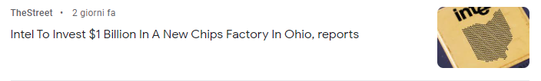Intel represents a giant in its industry, is a more solid investment option

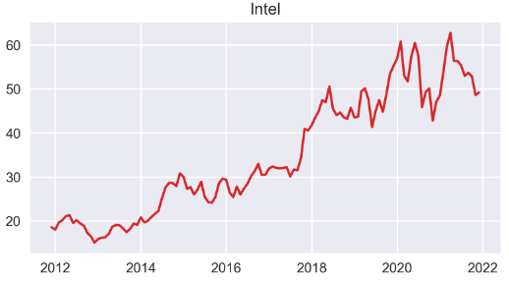

2.Descriptive statistics

# Yields

### Simples:

### Compounds

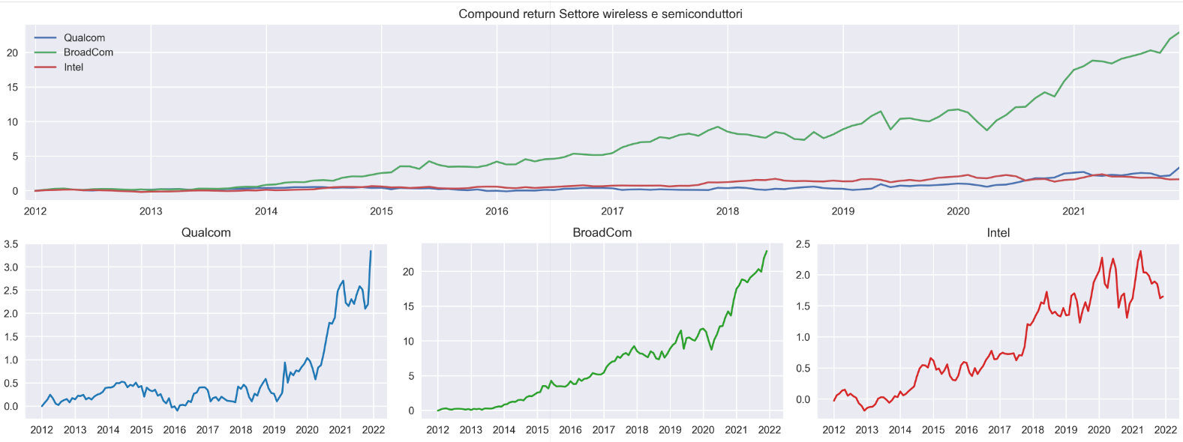

### Some considerations

* We can see that in general that in each sector the stocks are highly correlated with each other
* All stocks suffered the shock caused by the covid in early 2020, but have had a very good recovery
* Wireless stocks have had a significant boost in recent years due to the development and trade of new technologies (such as those related to 5G)
* Automotive stocks have experienced a similar boost due to increased adoption and development of electric and hybrid cars
* In all areas, the influence of inflation and Fed support for markets and low interest rate monetary policy is evident

### Distribution of returns

We can see from these distributions (but also from previous graphs); that some stocks, such as Tesla and Qualcom, have dispersions and therefore higher risks

## 4-section diagnostic charts:

* 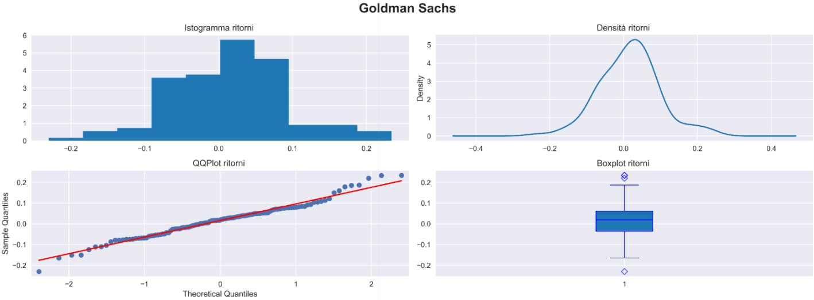Golden Sachs:
* 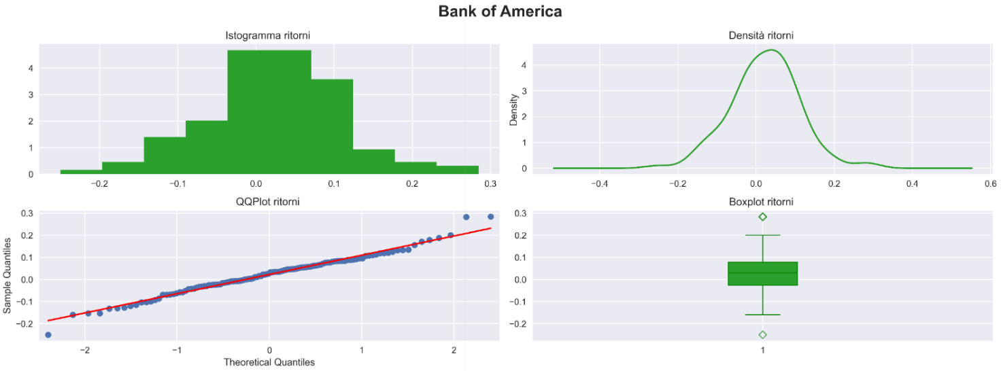Bank of America:
* 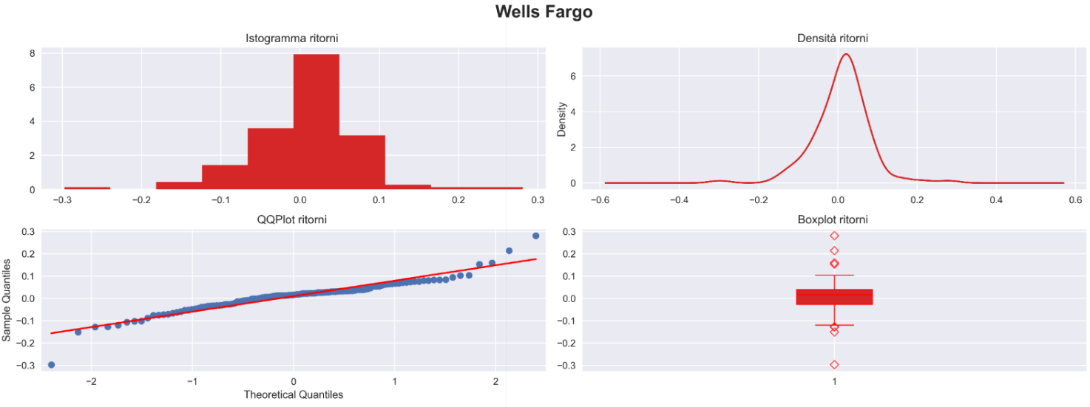Wells Fargo:
* 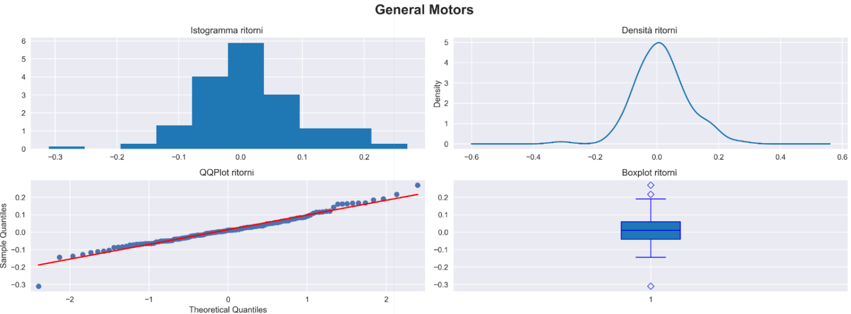General Motors:
* 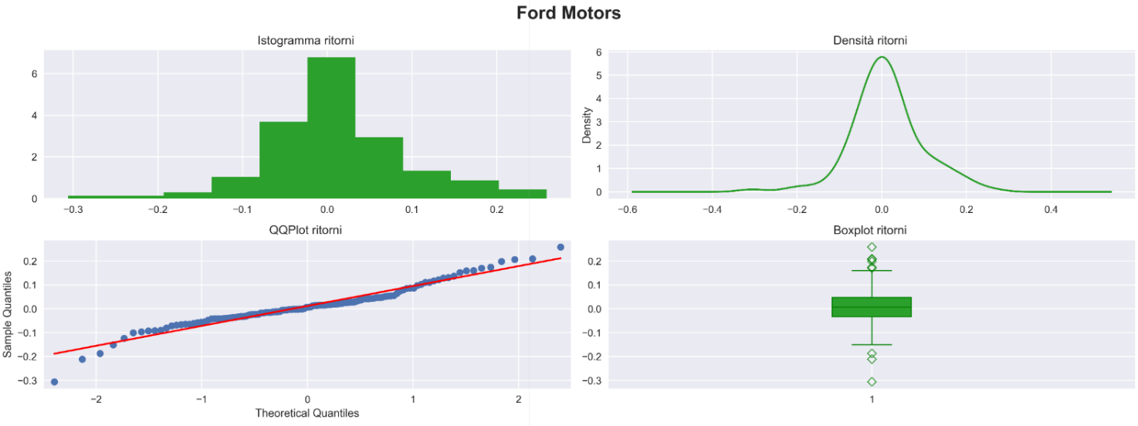Ford Motors:
* 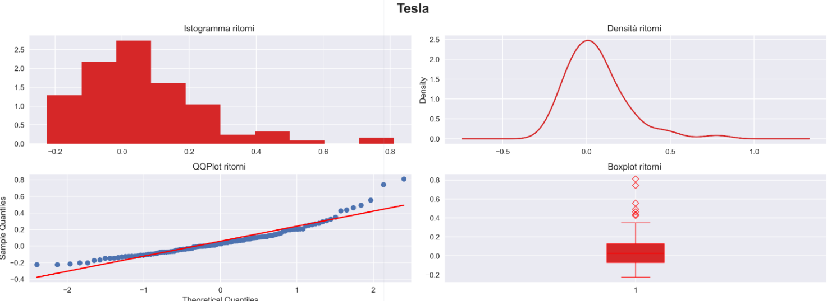Tesla:
* 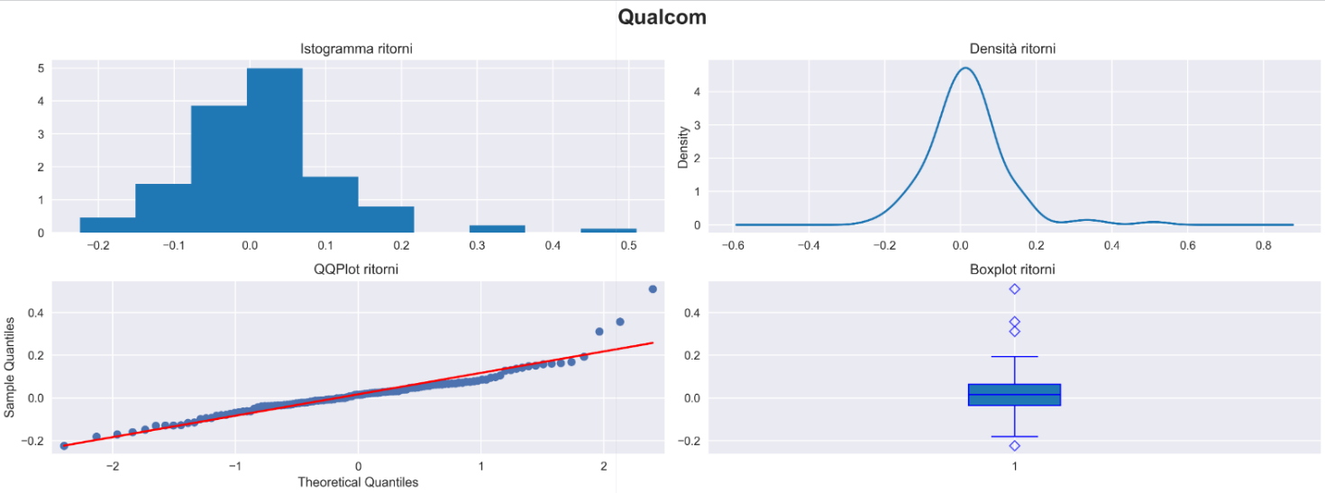Qualcom:
* 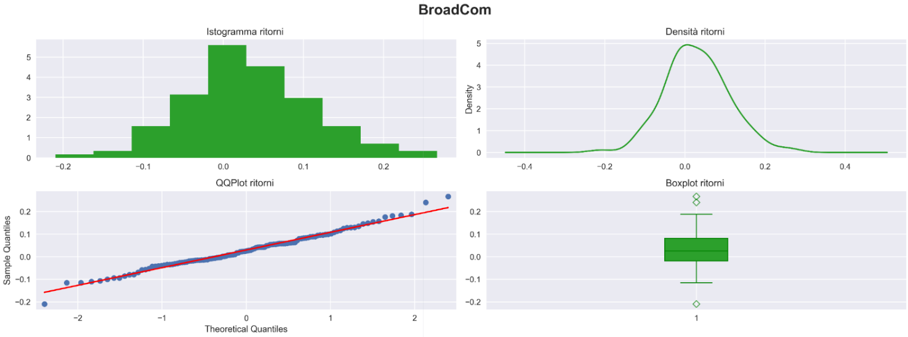BroadCom:
* 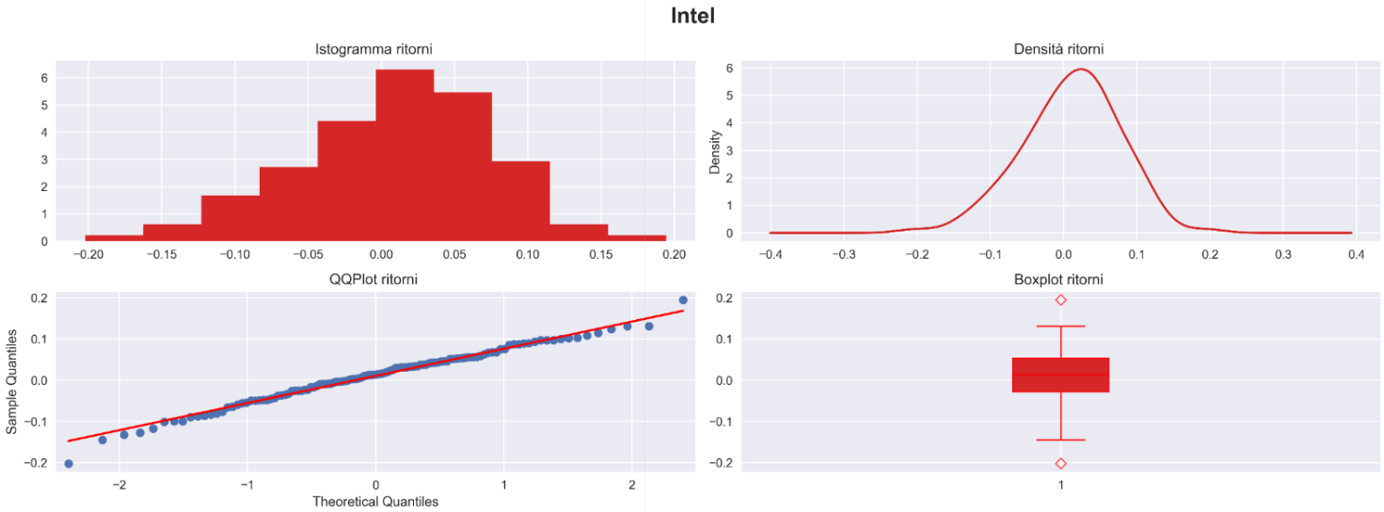Intel:

We can take advantage of the graphs previously shown to see how the returns are distributed, concentrated and divided in the quantiles.

We note that all stocks have similar distributions that tend toward a normal; exceptions are Wells Fargo, Tesla, and Qualcom whose returns are more centered toward the midpoint. In the case of Tesla we note a significantly more irregular dispersion than the others.

# Univariate descriptive statistics:

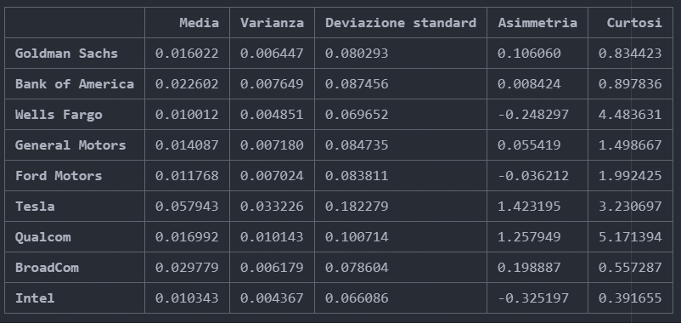

* The sharply higher-yielding stock is Tesla, while the lowest-yielding stock is Ford Motors
* Tesla and Qualcom confirm what had been noticed from the dispersion graphs, in fact, they have the highest standard deviation, instead the one with the lowest standard deviation is Intel
* From the graphs of returns we note that:
  + for all 3 sectors, volatility and returns have increased significantly in the last period (after the collapse due to covid).
  + For the automotive and wireless sectors, volatility remains low in the first period, but develops very high peaks thereafter
  + For the banking sector we have higher volatility (and returns) in the first period
* The stock with the returns most similar to a normal one is Intel, while the one with the returns furthest from a normal one is Qualcom (as can be seen from the kurtosis)

# Matrices of variances and covariances

### Variances

### Immagine che contiene testo, tabellonesegnapunti Descrizione generata automaticamenteCovariances

As we can see Tesla is the stock with the highest variance, this confirms the volatility expressed by the graphs of returns (and the distribution of such); we can therefore say that Tesla is the riskiest stock

Also, from the covariance matrix we note, as expected, a greater relationship of the covariance among stocks in the same sector, furthermore Tesla seems to have a relationship with Broadcom as well

# Correlations

### Averages in the sectors

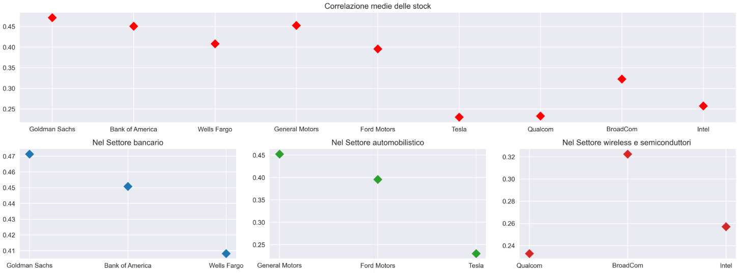

As noted in the first table, banking stocks are highly correlated, especially Goldman Sachs and Bank of America

Instead, the least correlated stocks are Qualcom and Intel, despite being part of the same industry

### Scatter of correlations

From the graph of correlations over time we note:

* For all series, the correlation starts high (due to lack of previous data on which to calculate the statistic), and then stabilizes at a lower point
* Particularly for the banking and wireless sectors, the correlation increases at the same time as returns rise sharply
* In the automotive sector we can see how Tesla becomes less and less correlated; this is a sign of the strong dominance of the electric subsector over the other two stocks

From the correlation scatter we obtain confirmation of the relationships expressed in the correlation matrix

### Mean correlations over time

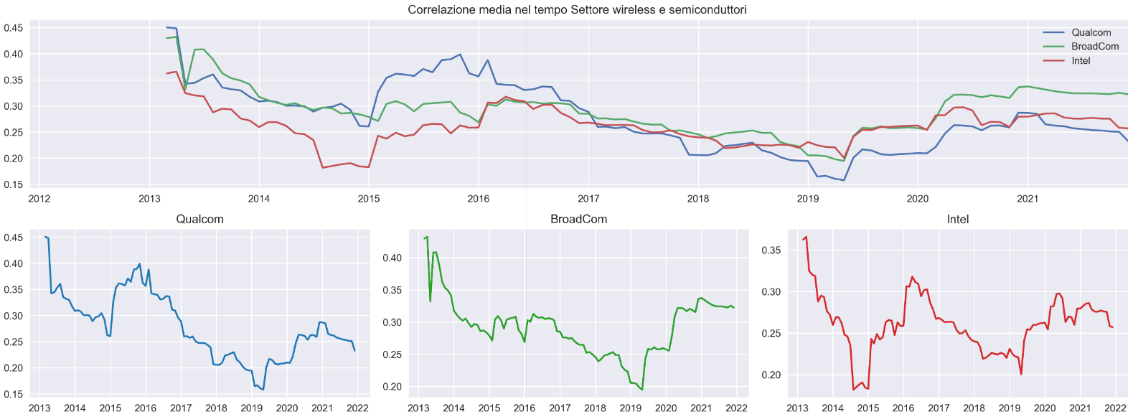

3.Forecast Analysis

## Description of the model and operation

The model is a multiple layer neural network, in which Dense and dropout layers alternate.

The neural network takes as input several previous days to output the next day's price.

In addition, the input days are shifted so that they are used to predict the price at the day equal to the offset set.

In this case the days used as input are 42 (2 working months), and the offset is 21 (1 working month)

## Validation set results

### Goldman Sachs

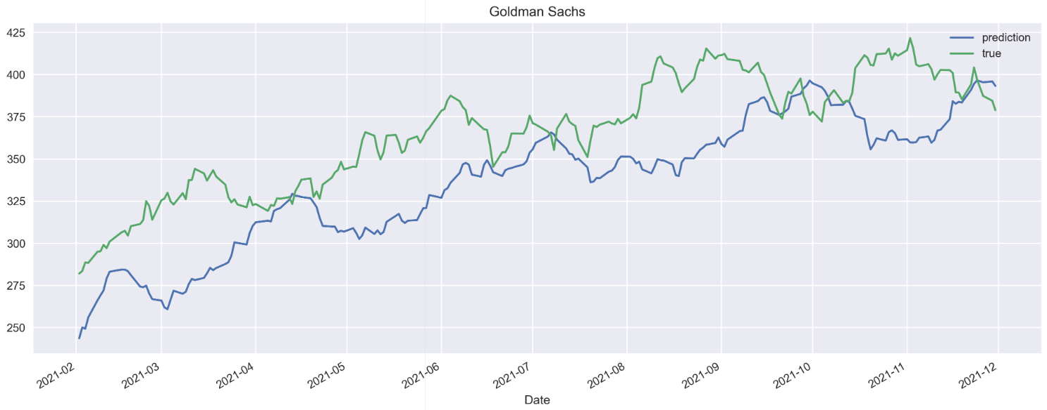

### Bank of America

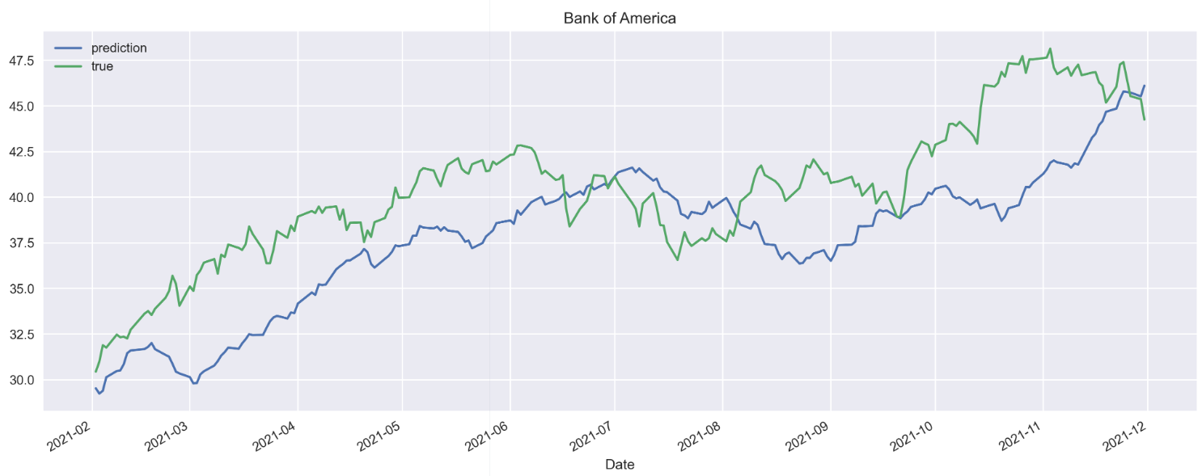

### Wells Fargo

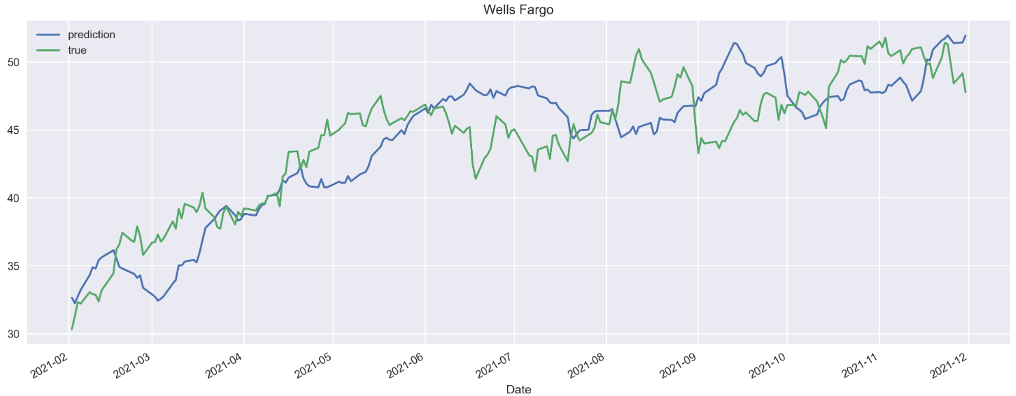

### General Motors

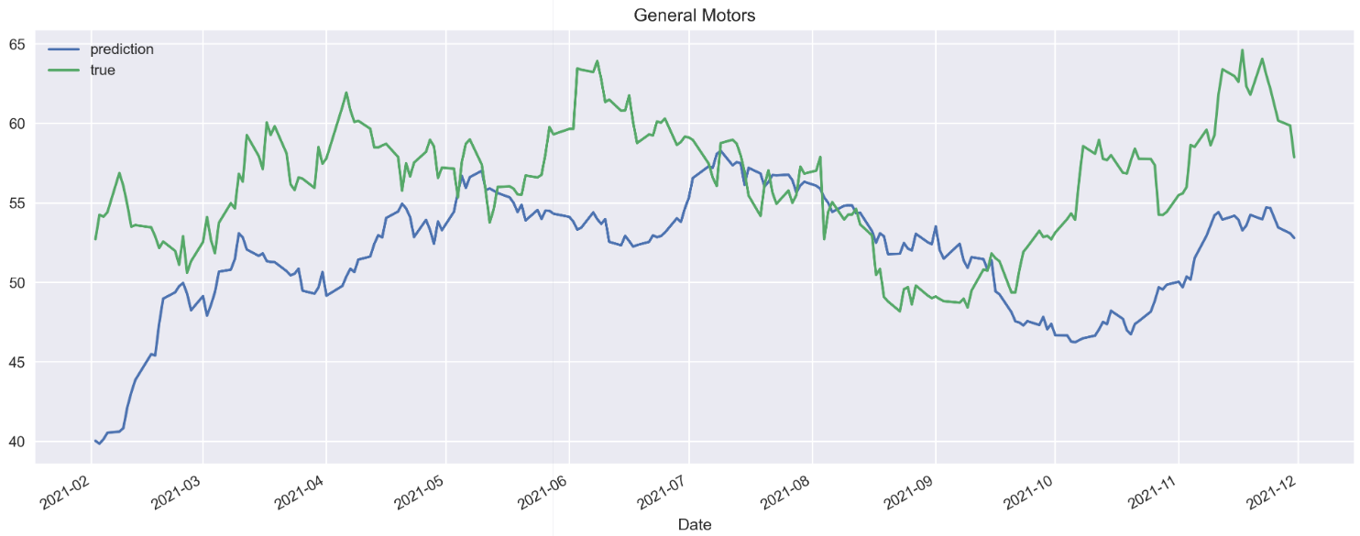

### Ford Motors

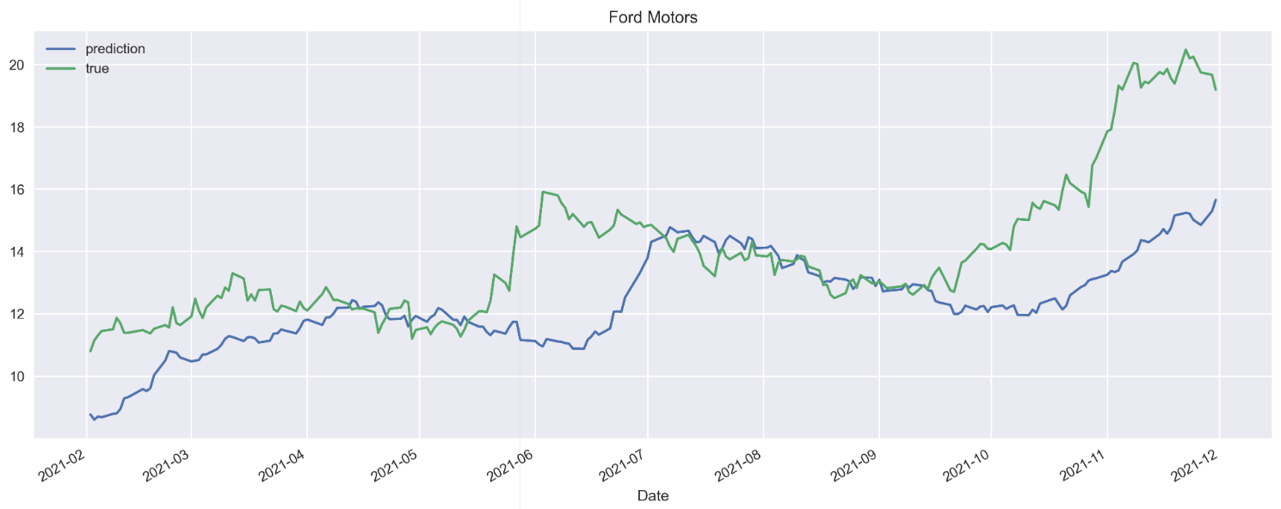

### Tesla

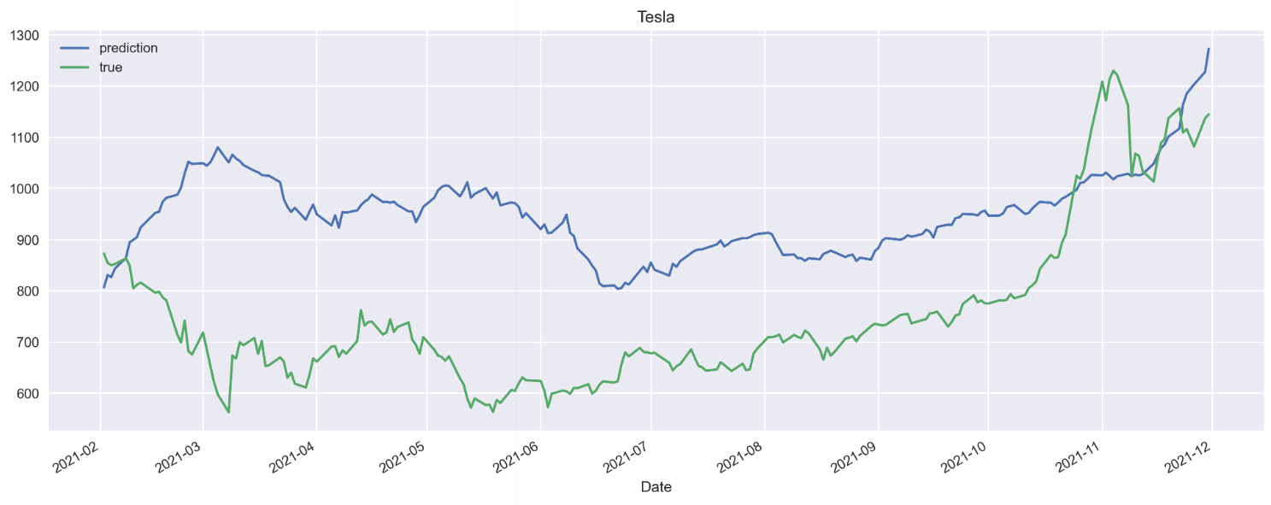

### Qualcom

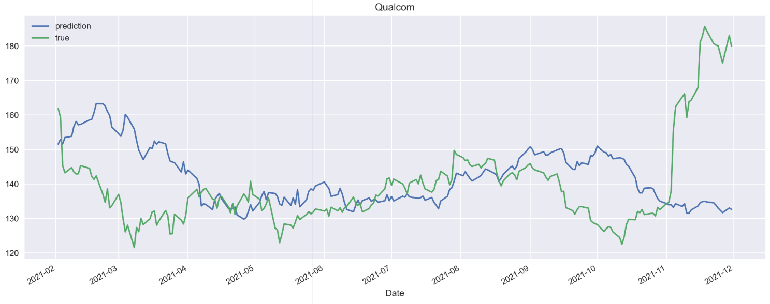

### BroadCom

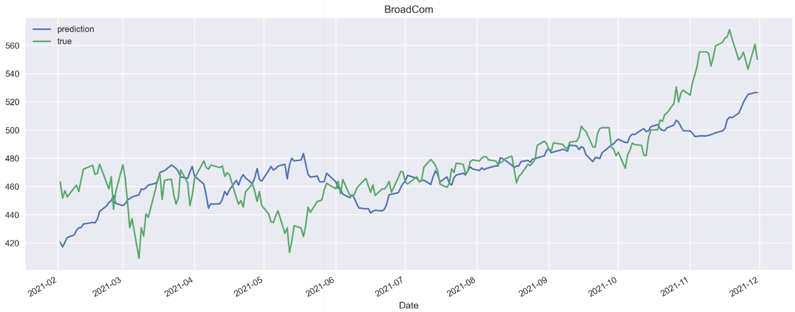

### Intel

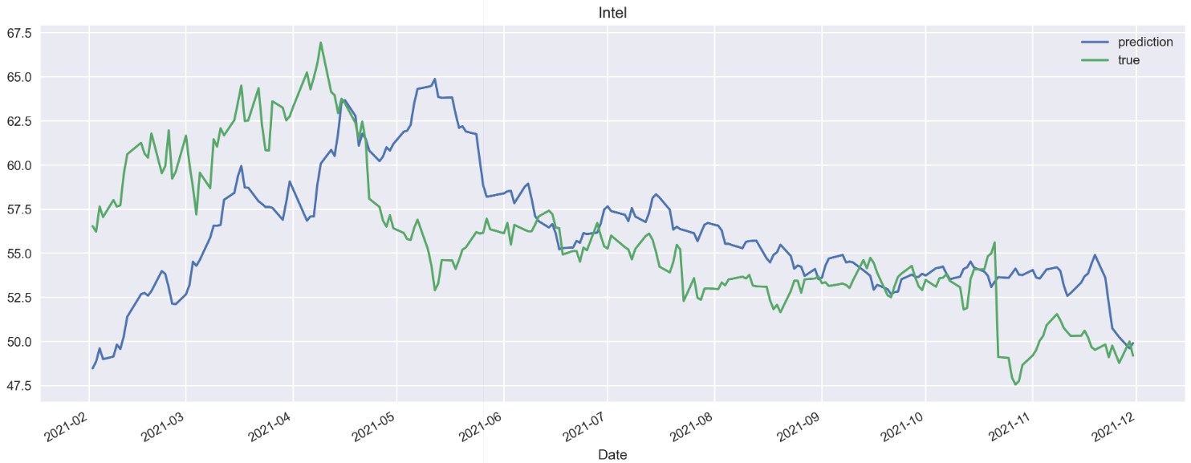

Some Considerations:

* The model seems to be able to predict the stock trend in general, but never anticipates it
* However, the predictions are inaccurate, especially when considered in the short term
* The model performs worse in more volatile stocks and better in less volatile stocks

4. Trading strategy

## Description of the strategy

The trading strategy is based on the use of the MACD indicator with Signal line; in fact, the signal is given by the crossing of the two MACD lines and Signal line

So: there is a buy signal when the MACD crosses from the bottom to the top of the Signal line, when the opposite happens we have a sell signal

Note: To simulate a more realistic environment (where the trader does not buy and see every day but merely anticipates the trend), a lock period of 14 days is set, with each new trade, in which no orders can be placed

## Results of the strategy compared with Buy and Hold

### Goldman Sachs

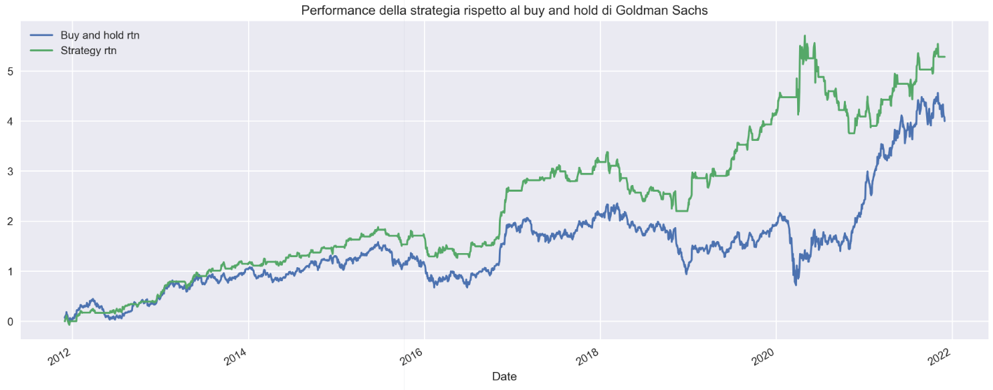

### Bank of America

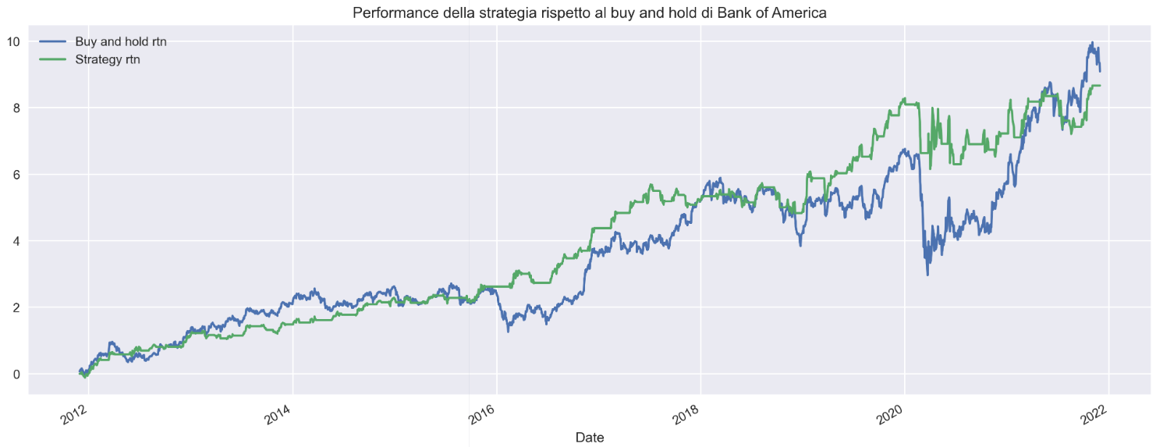

### Wells Fargo

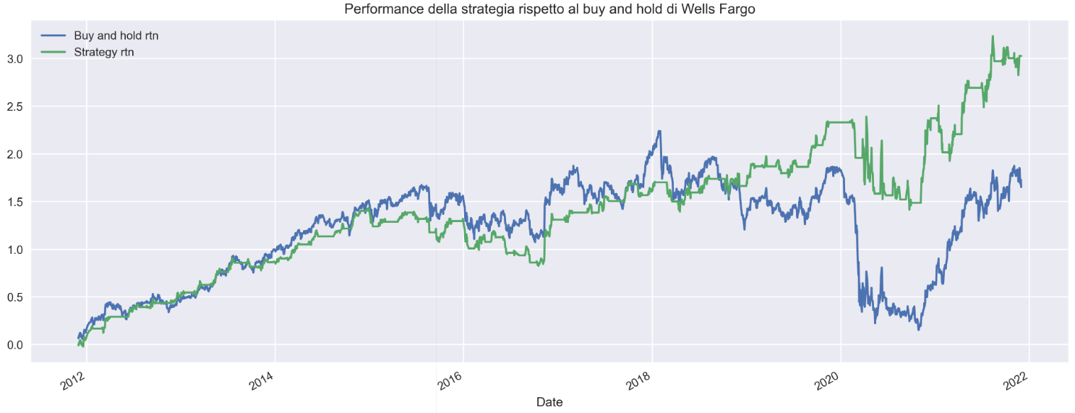

### General Motors

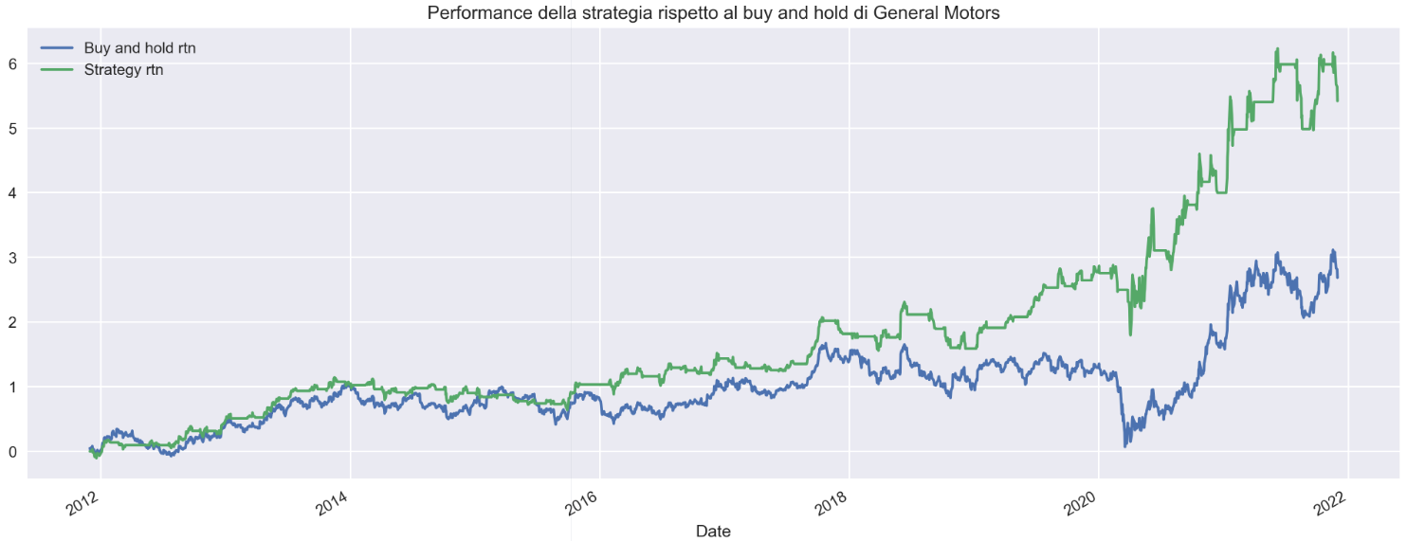

### Ford Motors

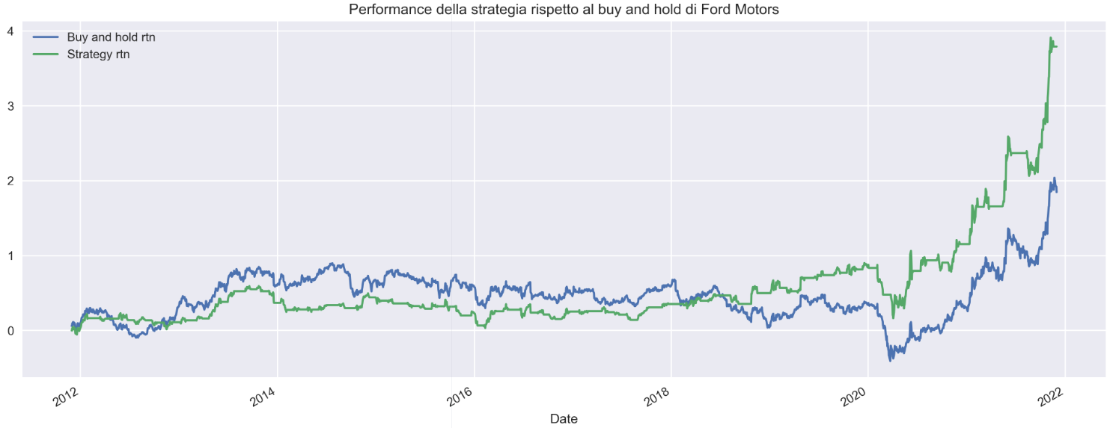

### Tesla

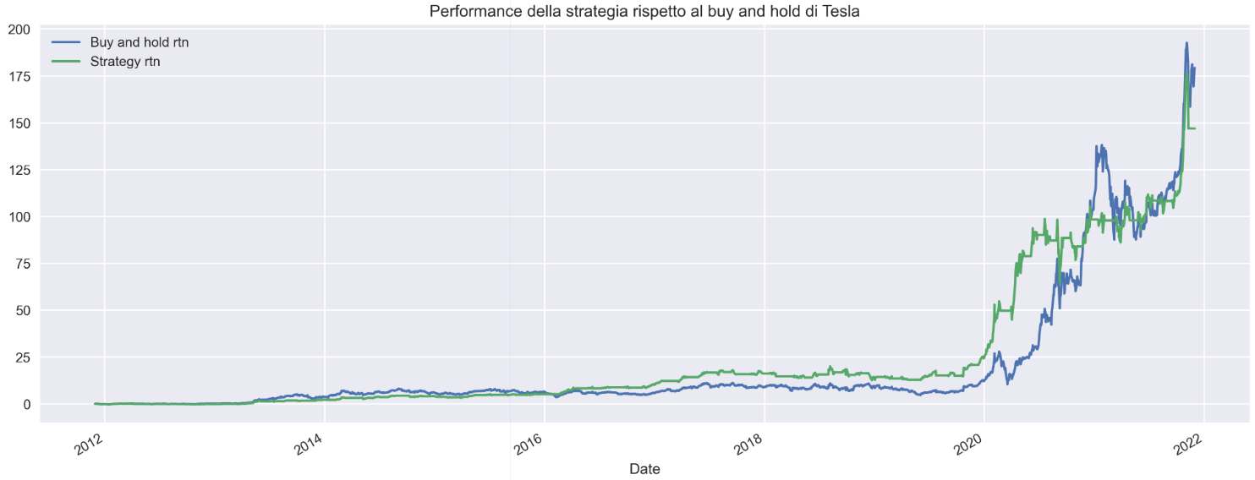

### Qualcom

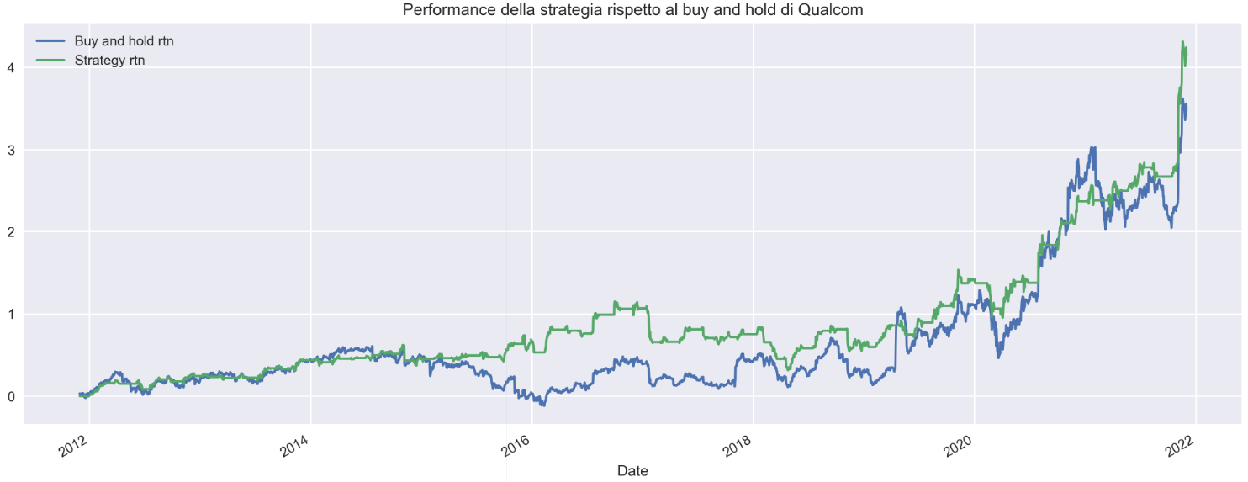

### BroadCom

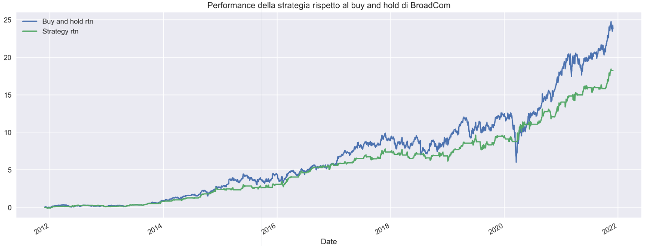

### Intel

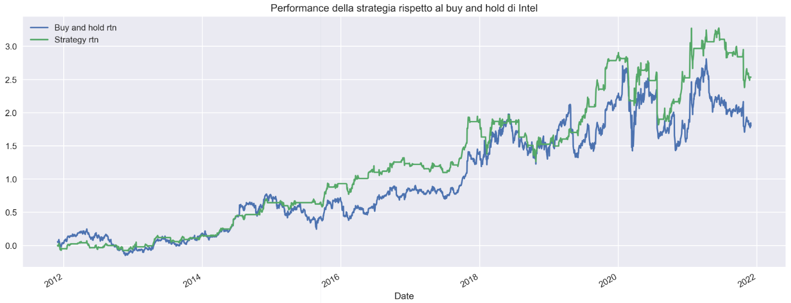

Some considerations:

* In most stocks the strategy performs better than Buy and Hold (not counting transaction costs), exceptions are Bank of America and BroadCom
* In many cases, performance is better because the strategy reduces the damage caused by the onset of the pandemic (especially in Wells Fargo and Goldman Sachs)
* You can see how the lock period creates a graph with constant horizontal lines

5.CAPM

## Beta

We can see that Tesla clearly emerges as the most market-correlated stock

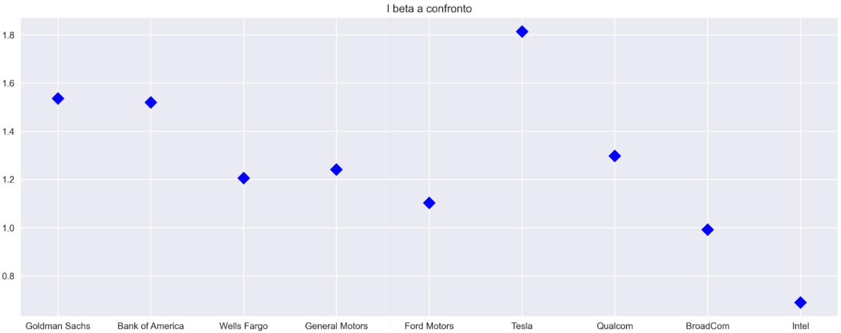

## Exposure to the 3 Fama-French risk factors.

## Gap between expected and actual returns

6. Portfolio

## Built with the first 108 months of data

### Analytical method

### method with Scipy

## Built with the 10 months stipulated in step 3

### Analytical method



### Method with Scipy

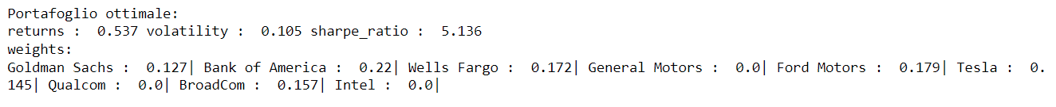

We can see that the use of the forecast data generates a portfolio with a very high sharpe ratio, due to the low volatility of the forecast

## Beta of the portfolio relative to the market



## Comparison of optimal and actual portfolio return

### Simple:

### Compound:

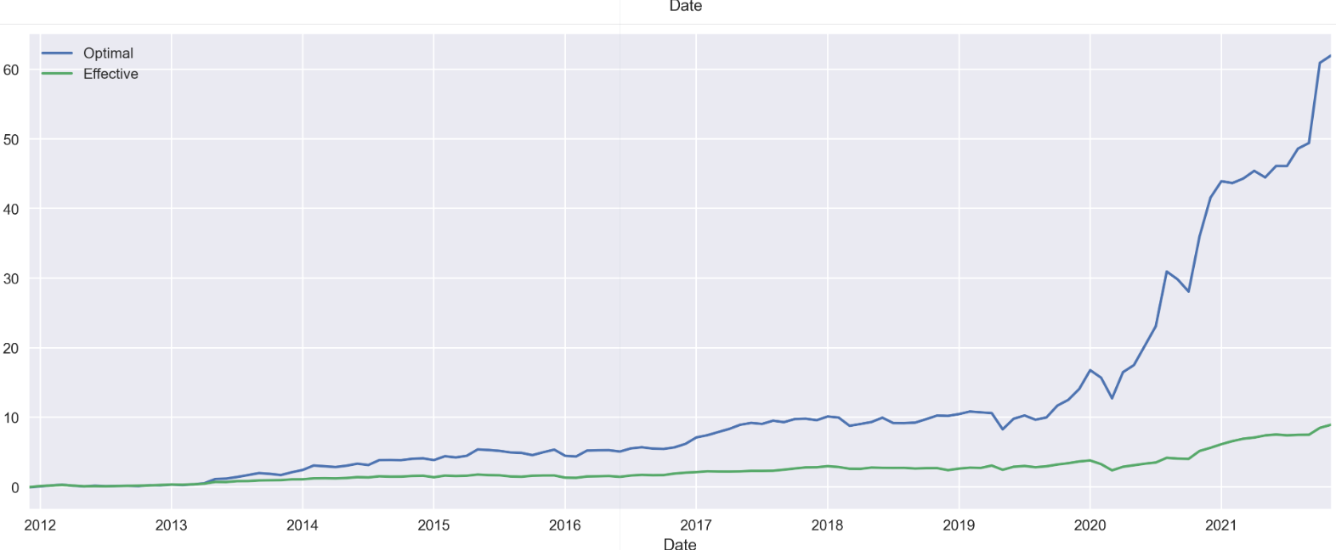

Through portfolio optimization we are able to achieve much higher returns. Definitely influenced by the strong presence of Tesla (37.3%), which had a return of 50% in 2021

Conclusions:

As we can see in the report, many of these stocks (especially BroadCom, Qualcom, and Tesla) are dangerous because of their volatility. Because they are part of new and emerging sectors and their intrinsic value is more difficult to calculate, in fact their price is driven a lot by speculation.

Other stocks such as banking and Intel appear to be more solid and less volatile.

The entire portfolio maintains a very high correlation with the market (>1), which makes it perform better and more dangerously depending on volatility.

Therefore, wanting to invest in such a portfolio, it would be useful to introduce stocks that are more stable and uncorrelated with the market; or one could introduce a Risk Free component or other more stable instruments such as gold.

Another solution would be to apply hedging strategies with put options to reduce risk.